**SOFTWARE ENGINEERING AND PROJECT MANAGEMENT**

**REGISTRATION NUMBER:-**

**RA1811003010530 – SHIKHAR SRIVASTVA**

**RA1811003010537 – RAHUL SINGH**

**RA1811003010539 – SHUBHANKAR TIWARI**

**PROJECT TITLE- TRAVEL TIP**

**CLASS DIAGRAM**

A class diagram in the [UML](https://en.wikipedia.org/wiki/Unified_Modeling_Language) diagram is **a type of static structure diagram** that describes the structure of a system by showing the system's classes, their attributes, operations (or methods), and the relationships among objects.

**NOTATIONS**

A class notation consists of three parts:

1. **Class Name**
   * The name of the class appears in the first partition.
2. **Class Attributes**
   * Attributes are shown in the second partition.
   * The attribute type is shown after the colon.
   * Attributes map onto member variables (data members) in code.
3. **Class Operations** (Methods)
   * Operations are shown in the third partition. They are services the class provides.
   * The return type of a method is shown after the colon at the end of the method signature.
   * The return type of method parameters is shown after the colon following the parameter name.
   * Operations map onto class methods in code

**Inheritance** (or Generalization):A solid line with a hollow arrowhead that point from the child to the parent class.

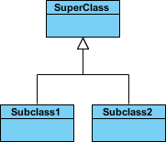

**Association**: A structural link between two peer classes. A solid line connecting two classes.

Simple association

**Aggregation**: A special type of association. It represents a "part of" relationship. A solid line with an unfilled diamond at the association end connected to the class of composite.

Aggregation

**Composition**: A special type of aggregation where parts are destroyed when the whole is destroyed. A solid line with a filled diamond at the association connected to the class of composite.

Composition

**Dependency**: Exists between two classes if the changes to the definition of one may cause changes to the other (but not the other way around). A dashed line with an open arrow.

Dependency

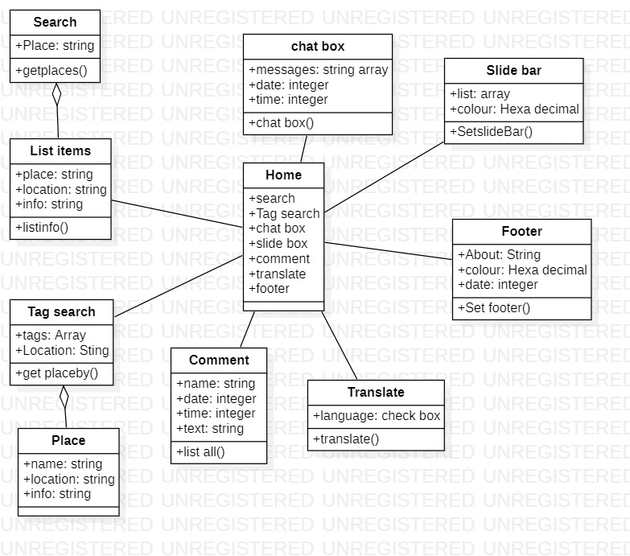

**CLASS DIAGRAM FOR TRAVEL TIP**

**DATA FLOW DIAGRAM**

Data flow diagrams are used to graphically represent the flow of data in a business information system. DFD describes the processes that are involved in a system to transfer data from the input to the file storage and reports generation.

**NOTATIONS**

**Process:** A process receives input data and produces output with a different content or form. Processes can be as simple as collecting input data and saving in the database, or it can be complex as producing a report containing monthly sales of all retail stores in the northwest region.

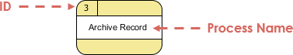

**Data Flow**: A data-flow is a path for data to move from one part of the information system to another. A data-flow may represent a single data element such the Customer ID or it can represent a set of data element (or a data structure).

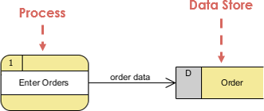

**Data Store:** A data store or data repository is used in a data-flow diagram to represent a situation when the system must retain data because one or more processes need to use the stored data in a later time.

DFD data store notation

**External Entity:** An external entity is a person, department, outside organization, or other information system that provides data to the system or receives outputs from the system. External entities are components outside of the boundaries of the information systems.

DFD external entity notation

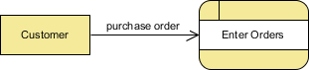

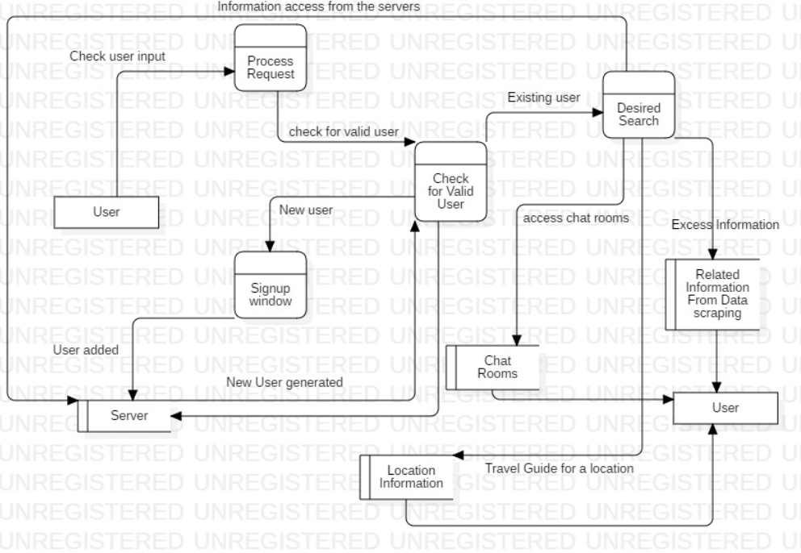

**DATAFLOW DIAGRAM FOR TRAVEL TIP**

**LEVEL 0 (REQUIRED ONLY AS THE PROJECT IS NOT VERY COMPLEX.)**

**SEQUENCE DIAGRAM**

Sequence Diagrams are interaction diagrams that detail how operations are carried out. They capture the interaction between objects in the context of a collaboration. Sequence Diagrams are time focus and they show the order of the interaction visually by using the vertical axis of the diagram to represent time what messages are sent and when.

**NOTATIONS**

**Actor:** a type of role played by an entity that interacts with the subject. An actor does not necessarily represent a specific physical entity but merely a particular role of some entity.

Actor

**Lifeline:** A lifeline represents an individual participant in the Interaction.

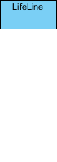

**Activations:** A thin rectangle on a lifeline) represents the period during which an element is performing an operation. The top and the bottom of the of the rectangle are aligned with the initiation and the completion time respectively.

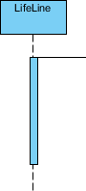

**Call Message:** Call message is a kind of message that represents an invocation of operation of target lifeline.

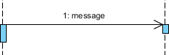

**Return Message:** Return message is a kind of message that represents the pass of information back to the caller of a corresponded former message.

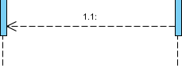

**Self Message:** Self message is a kind of message that represents the invocation of message of the same lifeline.

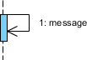

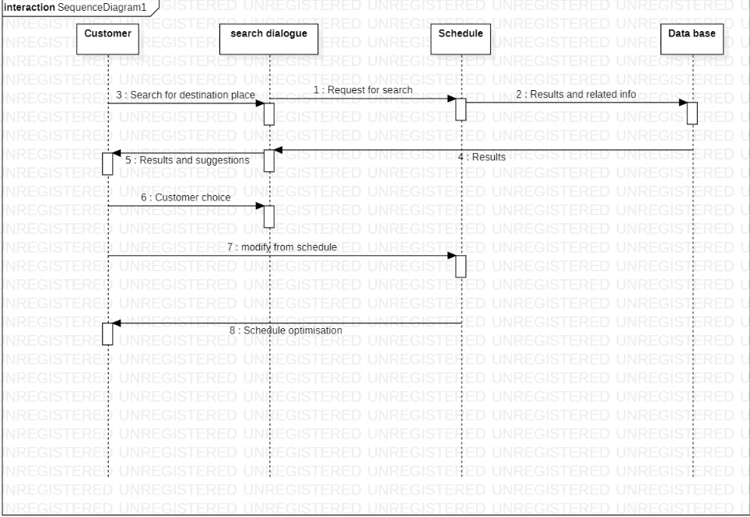

SEQUENCE DIAGRAM FOR TRAVEL TIP